

**Ahsanullah University of Science and Technology**

Department of Computer Science & Engineering

CSE 3104: Database Lab  
 Spring 2022

Final Project Report

Gym Management System

**Lab Group : A2**

**Project Group : 03**

**=: Submitted By :=**

Meherin Sultana 20200104036

Yasir Arafah Prince 20200104042

Ziyan Shirin Raha 20200104033

### 24 February, 2023

Table of Contents

1 Introduction 3

1.1 Proposed Goals 3

1.2 Project Accomplishments 3

2 Project Features 3

3 Database Diagram 4

3.1 Proposed Diagram 4

3.2 Evaluation 1 Diagram 5

3.3 Final Diagram 6

4 Contribution 7

5 Conclusion 7

5.1 Limitations 8

5.2 Future Work 8

5.3 Project Link 8

5.4 Ending Remarks 8

# **1 Introduction**

Our project is about the gym management system. A gym is a club or large room, usually containing special equipment, where people go to do physical exercise and get fit.

This project “Gym Management System” is a solution for fitness centers to manage the customers in an easier and more convenient way. The administrator can view all the members and the staffs working under them as well as their details. The administrator can also manage schedules, memberships, facilities and much more anytime, anywhere.

We have materialized 100% of our proposed project.

## **1.1 Proposed Goals**

This project is designed to facilitate a gym fitness center to automate its operations of keeping records and store them in the form of a large and user-friendly database.

As we know, benefits of gyms are numerous as it helps to increase the cardiovascular fitness, stronger muscles, decreased weight and so on. A good quality of gym can provide a safe environment for doing exercise and supervision by trained personnel. When an owner is establishing a gym, he needs to keep the large amount of data of the gym to get more revenue or to increase the facilities. So it motivated us to make a system to allow the concerned person to store and retrieve any type of record with just a single click of the mouse.

## **1.2 Project Accomplishments**

We have been able to complete our proposed project completely. In our project proposal, we hoped to manage all the data related to the gym. Like storing and retrieving data about members, staffs, managers, equipment, membership & packages etc.

After completion of the project, we can maintain all the details to provide valuable reports regarding the gym. The efficiency, interface, effectiveness, accuracy, information availability, easy maintenance makes our project different from other systems. We are pretty much satisfied with our project. If we had more time then we could have optimized it further.

# **2 Project Features**

The main goal of the project was to develop a system of improved facilities. The main features of our project are given below:

* Simple user interface design for the administrator
* Easy user navigation
* View the data in real time
* Accurately data entry
* Stored data can be retrieved easily from the frontend
* Automated processing rather than manual handling
* Reduced data inconsistency

In our proposed features, we kept the option for inserting values from the frontend. But while working on the project we realized that administrator can make some error while inserting the data. So we added edit or update option in the user interface. The modifications will be reflected on the other related forms too. We also added some queries in the implemented project to make it easier for the administrator to view data in an ordered manner in the tables of frontend.

# **3 Database Diagram**

Here are the entity-relationship (ER) diagrams of our project.

## **3.1 Proposed Diagram**

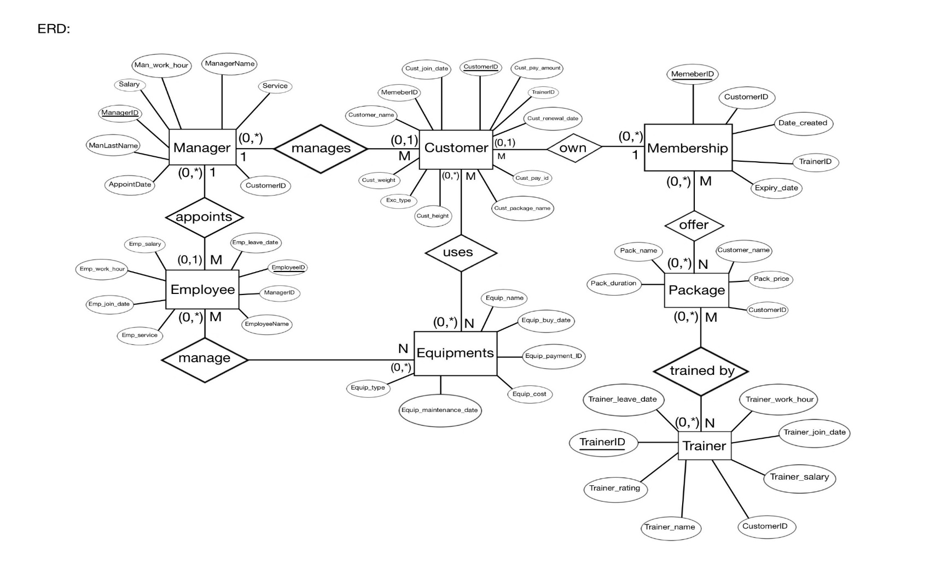

**Figure 1:** Proposed Diagram

**Limitations:**

* We have changed the table name from “Employee” to “Staff” and also some attributes which were clashing with other attributes.

## **3.2 Evaluation 1 Diagram**

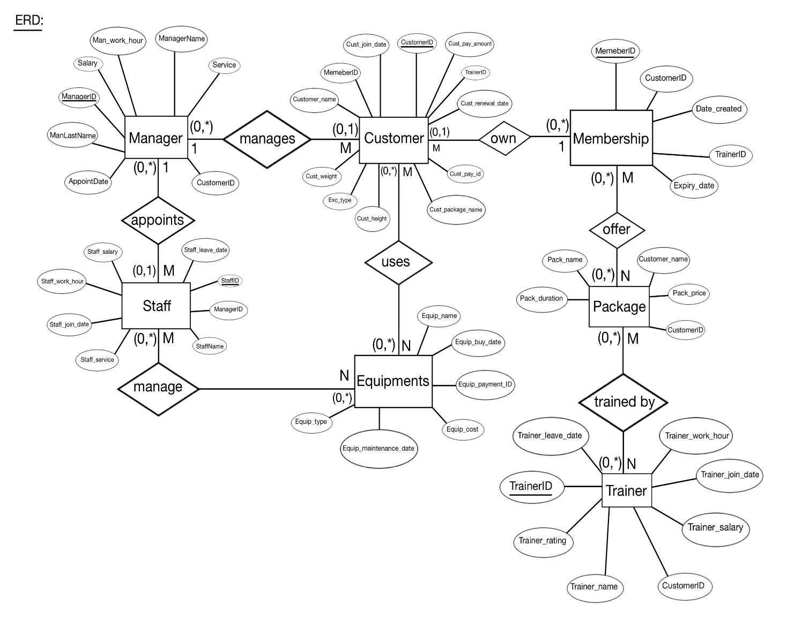

**Figure 2:** Evaluation 1 Diagram

**Limitations:**

* Functional Dependency has occurred during the table creation.

## **3.3 Final Diagram**

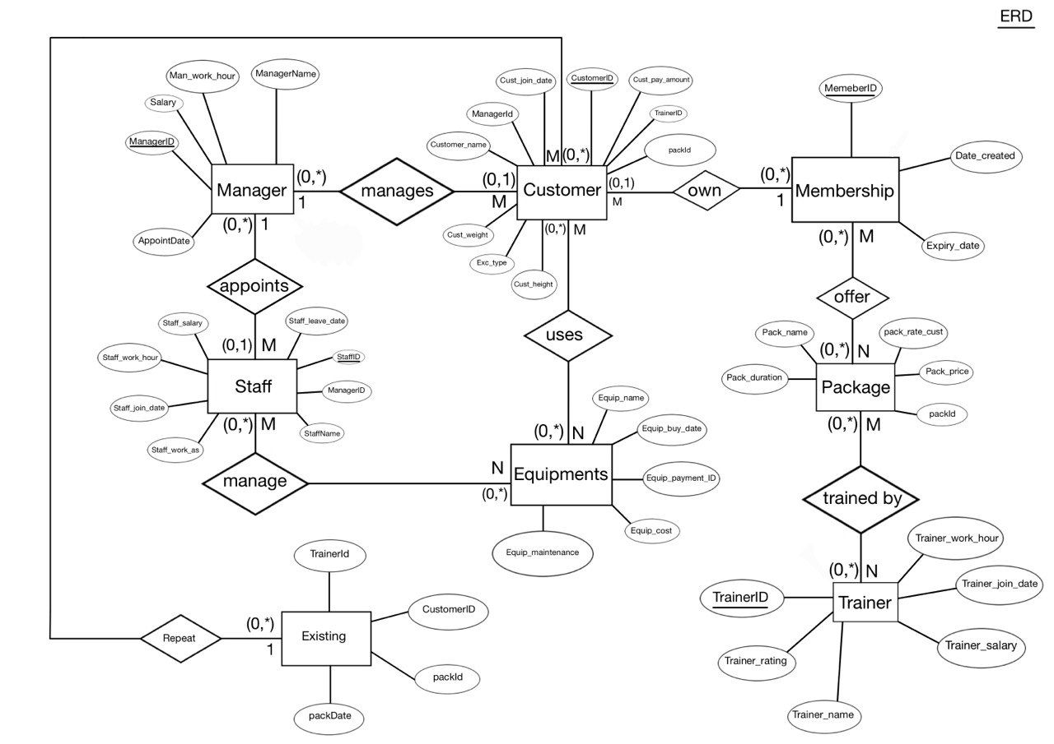

# **4 Conclusion**

The system developed is able to meet all the basic requirements. The management will also be benefitted by the system as it automates the whole procedure. The workload of the concerned will be reduced. The main advantage is, this system is flexible for future modifications. The main focus was to cover all the user requirements and make it more user friendly.

## **4.1 Limitations**

The main drawback of our project is customers don’t get access for the gym center as our project is gym owner oriented. So the communication with the members are not well. From the owner’s side, one limitation could be when there will be a huge amount of data it may be an inconvenient to look for a certain information from the tables as there are no search options in the user interface.

## **4.2 Future Work**

If we got enough time for the project, then we could have solved the limitations of our project. In future if we get the opportunity to work or optimize further, we will keep the signup option for customers. Then the customers will be able to view their own data in real time. Also, they will be able to give feedbacks about their own experience about the gym. The owner can improve the gym facilities according to the feedbacks.

## **4.3 Ending Remarks**

Management system helps to determine business decisions and organize everything effectively. So using database in managing those data can help us seamlessly.